Page 1
Delivering Excellence in Infrastructure & AI Solutions
Delivering excellence in infrastructure services and cutting-edge AI solutions for modern businesses.
Our Business Divisions
Two specialized divisions delivering excellence across infrastructure and AI innovation
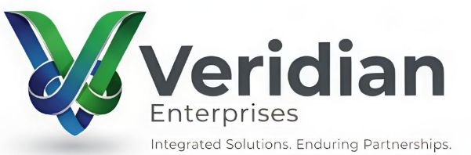  Veridian Enterprises  Infrastructure & Project Services  Services across construction, fabrication, and workforce solutions. Currently under development. | 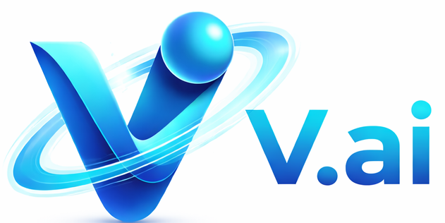  V.ai  AI Products & Business Automation  AI-powered products and services helping businesses automate processes and improve efficiency.

Building the Future of Business
From physical infrastructure to digital transformation, Veridian delivers comprehensive solutions that drive growth and innovation across industries.

Page2
V.ai
Practical AI Solutions for Marketing, Sales, and Operations
V.ai builds AI-powered agents and automation solutions that help businesses communicate better, work faster, and operate more efficiently — with control, clarity, and real-world usability.

Who We Are
AI, Made Practical
V.ai is the AI innovation arm of Veridian Enterprises, focused on delivering usable, cost-effective AI solutions for businesses.
We work with organizations looking to adopt AI in a simple, meaningful, and results-driven way — not experimental or over-engineered systems.

What We Do
AI That Works Across Your Business
V.ai designs purpose-built AI solutions that support everyday business functions — from content publishing and outbound calling to appointment scheduling.
Our focus is not experimentation or hype.
We build usable AI products that integrate into real workflows and deliver measurable value.
Our Core Offerings
V.ai Publish  AI-powered content creation and multi-platform publishing with human approval. | V.ai CallAssist  AI-assisted outbound calling to support sales, follow-ups, and customer outreach. | V.ai Schedule  AI-driven appointment booking and calendar coordination for professionals and service businesses.

1 | V.ai Publish- AI Content Creation & Publishing  AI-Powered Content Creation & Multi-Platform Publishing  V.ai Publish helps businesses create, approve, and publish content across multiple social platforms — quickly, consistently, and without editing skills.  From a simple image and short caption, our AI transforms your idea into ready-to-publish video or visual content, with full human approval before it goes live.  What It Does  - Converts images and short captions into engaging video content  - Supports 40+ languages for global audiences  - Publishes across multiple social platforms from one workflow  - Includes human-in-the-loop approval for full control  - Requires zero editing or design skills  How V.ai Publish Works  - Upload & Describe  Upload an image and add a short 3–4 line caption describing how you want the content.  - AI Processing  The AI generates a short video or visual post and sends it for review.  - Review & Approve  Preview the content. Approve it or reject it with one click.  - Publish Everywhere  Approved content is automatically posted across all connected platforms.  Why Businesses Use V.ai Publish  - Create content in seconds, not days  - Maintain brand control with approval workflows  - Eliminate dependence on editors or agencies  - Scale content across platforms effortlessly  - Ideal for teams with limited marketing resources
2 | V.ai CallAssist- AI-Assisted Outbound Calling  AI-Assisted Outbound Calling & Voice Engagement  V.ai CallAssist is an AI-powered outbound calling solution designed to support sales, follow-ups, reminders, and customer outreach — while maintaining human oversight and compliance.  It enables businesses to scale outbound communication efficiently, without fully replacing human agents.  What It Can Be Used For  - Sales outreach and lead engagement  - Appointment confirmations and reminders  - Customer follow-ups  - Feedback and survey calls  - Information and notification calls  Key Capabilities  - Natural, human-like voice interactions  - Configurable call scripts and flows  - Real-time call monitoring and controls  - Human handover when required  - Call logs and conversation summaries  How V.ai CallAssist Works  - Define the Use Case  Identify call purpose, script, and target audience.  - AI-Driven Calling  The AI agent places outbound calls and interacts using predefined flows.  - Human Oversight  Calls can be monitored, reviewed, or escalated to human agents.  - Insights & Reporting  Call outcomes and summaries help optimize future outreach.  Why Businesses Use V.ai CallAssist  - Scale outbound calling without increasing headcount  - Maintain consistency in messaging  - Reduce manual agent workload  - Improve reach and response rates  - Support compliance and transparency  Who It’s For  - Sales and business development teams  - Customer support and service teams  - Businesses running outbound engagement campaigns
3 | V.ai Schedule- AI Appointment Booking & Scheduling  AI-Powered Appointment Booking & Calendar Management  V.ai Schedule is an AI-driven appointment booking solution that handles inbound calls, schedules appointments, blocks calendars, and sends confirmations — all with accuracy and coordination across both parties.  It acts as an AI-assisted scheduling agent, ensuring appointments are booked correctly and efficiently, without manual intervention.  What It Can Be Used For  - Doctor and clinic appointment booking  - Professional and corporate scheduling  - Service-based businesses and offices  - Consultation and meeting coordination  Key Capabilities  - Answers inbound calls for appointment requests  - Confirms availability for both parties  - Automatically books and blocks calendars  - Sends email confirmations to all participants  - Supports rescheduling and cancellations  How V.ai Schedule Works  - Inbound Call Received  The AI agent answers incoming calls and identifies appointment requests.  - Availability Check  The system checks real-time availability for the doctor or professional.  - Appointment Confirmation  The appointment is booked and calendars are updated for both parties.  - Notifications Sent  Email confirmations are sent to all participants with appointment details.  Why Businesses Use V.ai Schedule  - Reduce missed or double bookings  - Eliminate manual scheduling effort  - Improve response time for callers  - Ensure accurate calendar coordination  - Operate 24/7 without additional staff  Who It’s For  - Healthcare providers and clinics  - Professional services (legal, consulting, finance)  - Corporate offices and service businesses  V.ai Schedule is designed to operate within organizational policies and applicable regulations, ensuring secure handling of scheduling and communication data.

Why V.ai
Built for Real Businesses, Not Just AI Demos
Businesses choose V.ai because we take a practical, responsible approach to AI adoption.
What sets us apart:
- Business-first AI design
- Human-in-the-loop control for critical interactions
- Scalable solutions without heavy upfront investment
- Transparent workflows and measurable outcomes
- Designed for responsible and compliant deployment
We believe AI should assist teams, not replace them blindly.

Who We Work With
Supporting Teams at the Right Stage of AI Adoption
V.ai works with organizations that want to adopt AI without complexity or disruption.
We typically support:
- Small and mid-sized businesses
- Startups and growing companies
- Marketing and sales teams
- Healthcare and professional service providers
- Organizations exploring AI-driven automation
If you’re asking “Where can AI actually help us?” — you’re our ideal client.

About V.ai
AI Solutions, Built with Purpose
V.ai is the AI solutions initiative of Veridian Enterprises, created to help businesses adopt AI in a clear, controlled, and cost-effective way.
Our mission is simple:
Deliver AI that works in the real world — not just in theory.
We combine automation, intelligence, and human oversight to build solutions businesses can trust and scale.
Call to Action
Ready to Explore AI for Your Business?
Whether you’re looking to automate content, scale outreach, or streamline scheduling, we’ll help you identify the right AI approach — without unnecessary complexity.
- Contact Us
- Request a Demo
- Contact via email: info@veridiangroup.in

